rd Assignment
Create a newsletter using Microsoft Word. You are a member of a charity, and you are tasked monthly to create a newsletter in which you post current events and information related to the charity. The Charity can be a real or imagined charity. This assignment will use a table to create the structure of the newsletter. Please read through the remaining directions and information
NOTE: No templates are to be used for this assignment
1. Change the margins of the document to narrow (.5 inch top, bottom, left and right). 2. You will have a title at the top of the newsletter. You can put in Charity News as the title or create your own title related to the charity. Change the title to be centered and heading one style. Change font color and font name of the title from what is set by default. Font size should be 48 size font. 3. Below the title, you will create a 2 column by 3 row table. In each row, you will have a picture or image in one cell and a brief write up of an event or news you want to share about the charity in the other cell in the row. Adjust the size of the images, so the newsletter fills the page to look like a newsletter. 4. Ensure the table is centered on the page by selecting the table and using the center button. It is optional if you would like to change cell shading in any of the cells of the table. 5. Below the table, put in the words POC Information, your name, any email and phone number. This should all be centered. (POC stands for Point of Contact.) 6. The newsletter will be one page in length. 7. In the footer add in yourLastNameYourFirstInitial_YourGIDNumber. 8. Save the file as CS105_wk4_YourLastNameYourFirstInitial_YourGIDNumber and upload it in the week 4 assignment area of the course. Example:


Grading Criteria Assignments Maximum Points
Change margins to narrow 4 Newsletter title created, centered, heading 1 style 10 Change font color, and font name of the title. Change font size should be 48 size font. 6 Create a table with specified rows and columns 30 Place a image/picture in a cell in each row and information in other cell in each row 15 Adjust contents of newsletter to fill space properly to look like a newsletter 10 Center the table 4 POC Information and then your name and any email and phone number placed centered below the table. 6 Newsletter is one page 5 Include footer with specific information 5
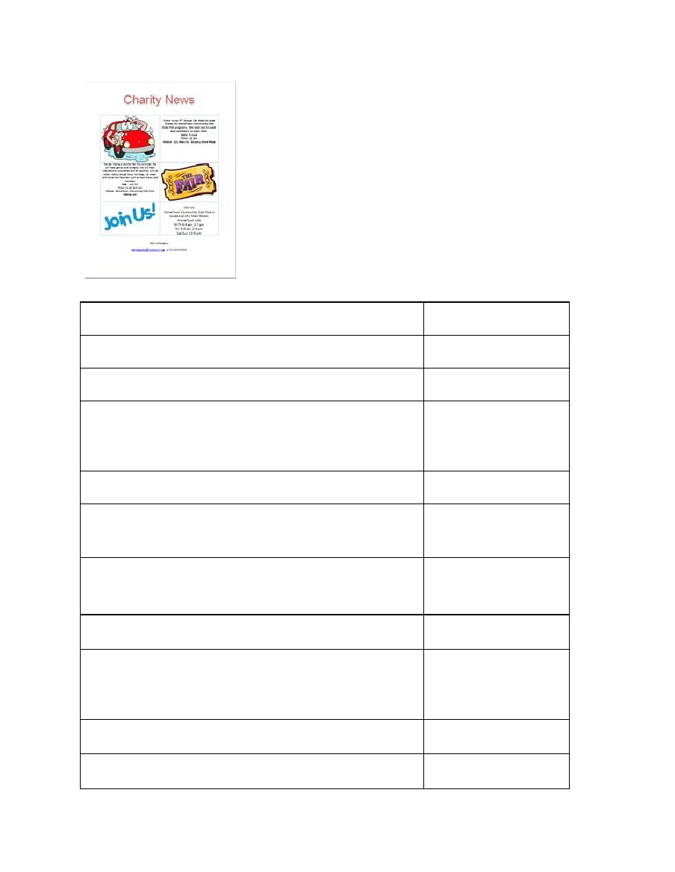

Save the file with a specific name 5
Total
100


